Deploy an app using python Flask server using Dockerfile

- Use Image: ubuntu:latest

- Install all required dependencies

# apt install -y python3 python3-setuptools python3-dev build-essential python3-pip

- Install & Configure Web Server

# pip3 install flask

- Copy the code from host os to container's path /mnt.

# cat > app.py

import os
from flask import Flask
app = Flask(__name__)

@app.route("/")
def main():
return "Welcome!"

@app.route('/cdac')
def hello():
return 'Hey, how are you?'

if __name__ == "__main__":
app.run(host="0.0.0.0", port=8080)

- Expose port 5000 on host & 8080 within container.

- Start/Entrypoint Web Server
# python3 /mnt/app.py

Containerising a Python Flask web application using Dockerfile to build and a docker-compose.yml file to manage and run the container easily.

Step 1: The Code (app.py)
Save this code into a file app.py
import os
from flask import Flask
app = Flask(__name__)
# Imports the tools needed to build a web server and creates a Flask application.
@app.route("/")
def main():
return "Welcome!"
# It tells the server to display the text "Welcome!" whenever someone visits the main homepage.
@app.route('/cdac')
def hello():
return 'Hey, how are you?'
# It displays the text "Hey, how are you?" when a user navigates to that sub-page.
if __name__ == "__main__":
app.run(host="0.0.0.0", port=8080)
# By default, Flask only listens to its own environment. Setting the host to 0.0.0.0 ensures the server can accept requests coming from outside the Docker container.

Step 2: Creating the Dockerfile

FROM ubuntu:latest

# Downloads a clean, official Ubuntu operating system image to use as base.

RUN apt update && apt install -y python3 python3-setuptools python3-dev build-essential python3-pip
# A standard Ubuntu image does not come with Python or compiler tools. We must install them so our code can run

RUN pip3 install flask --break-system-packages

# Our app.py relies on Flask. We add --break-system-packages because modern Ubuntu versions prevent global pip installs to protect system files; this bypasses that warning safely inside a container. (info from google)

COPY app.py /mnt/app.py
# Copies the app.py file from your local computer (the host OS) into the /mnt directory inside the container.

EXPOSE 8080
#The application inside the container listens on port 8080

CMD ["python3", "/mnt/app.py"]
# executes automatically the moment the container boots up.

Step 3: Creating the docker-compose.yml
Create a file named docker-compose.yml in the same folder.
Services: #Initiates the list of containers you want to build and run
Web_server: # Name of the container.
build: . #Tells Docker Compose to look in the current folder (.) for a Dockerfile and build it.
ports:
- "5000:8080" #Maps a port on your local computer to a port inside the container

OUTPUT
Ensure all three files (app.py, Dockerfile, and docker-compose.yml) inside the same folder. Open the terminal, go to that folder, and run:
docker compose up -d
Once the terminal says the server is running, open web browser and goto:
- http://localhost:5000/ (Displays "Welcome!")
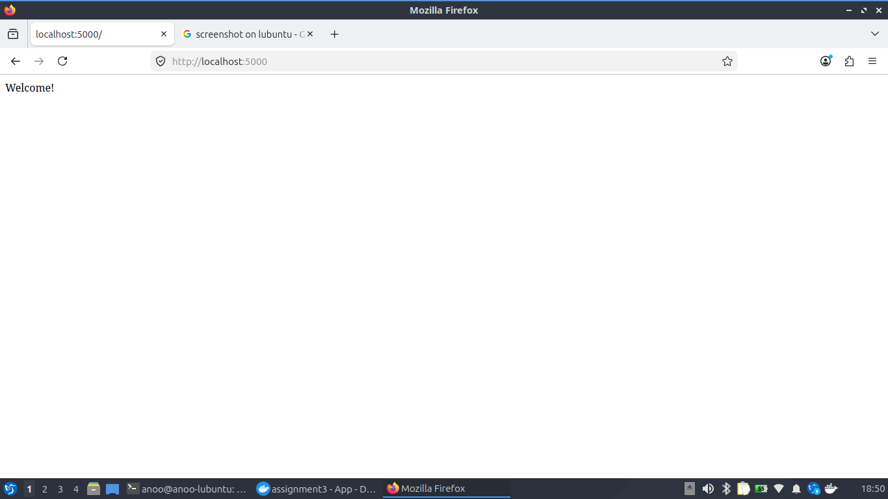
- http://localhost:5000/cdac (Displays "Hey, how are you?")

